Enterprise VPC Networking Design Documentation

Overview

This document describes a production-grade AWS VPC network architecture designed for long-term scalability, security, and auditability. The design follows enterprise CIDR planning standards and strict routing-based internet control.
Vpc=virtual private cloud
Your company’s private data center, but in the AWS cloud.

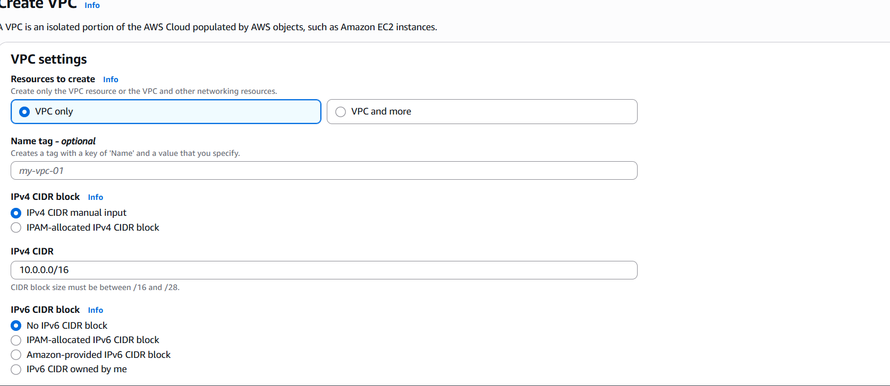

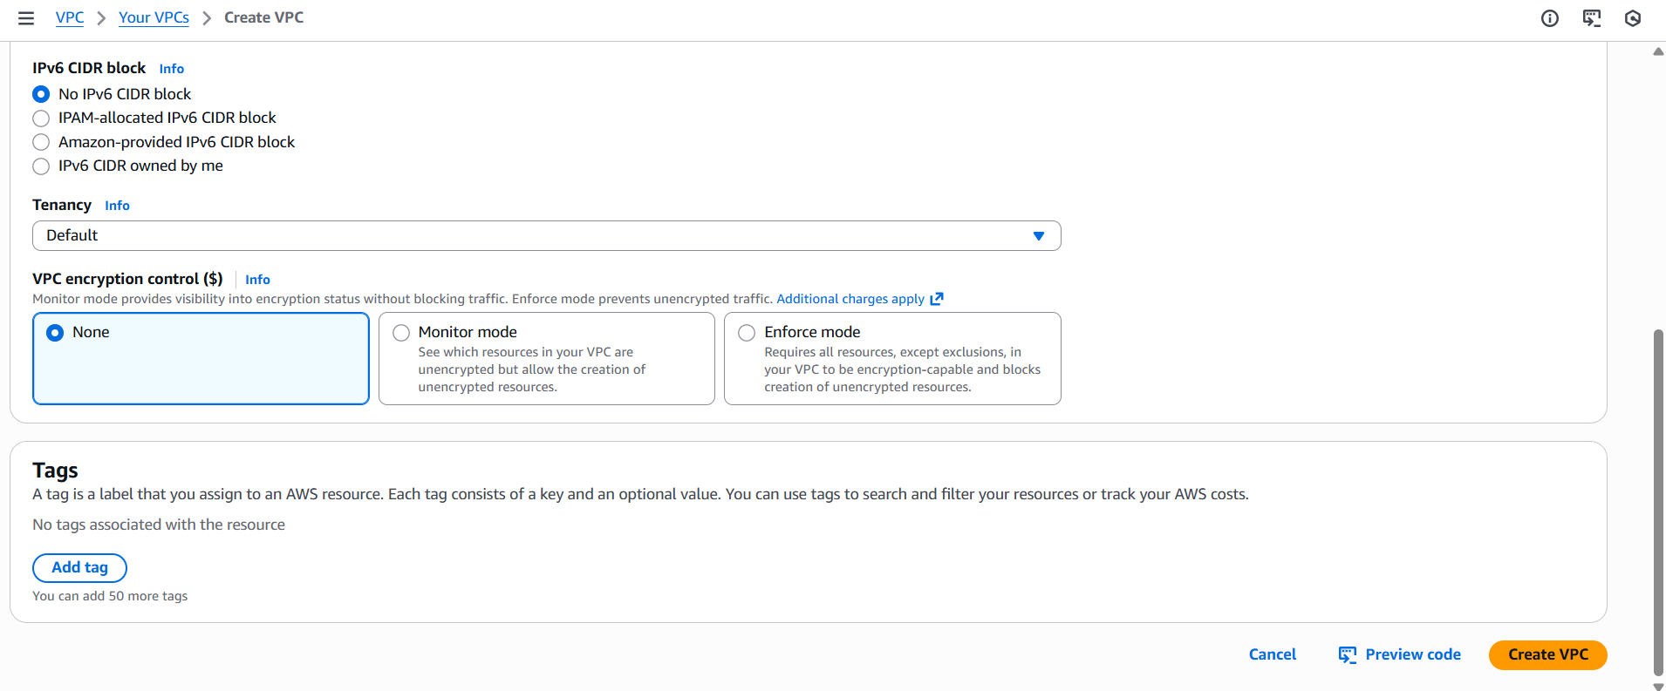

Creating subnets
A subnet is a smaller network inside a VPC.
VPC = big network
Subnet = a piece of that network
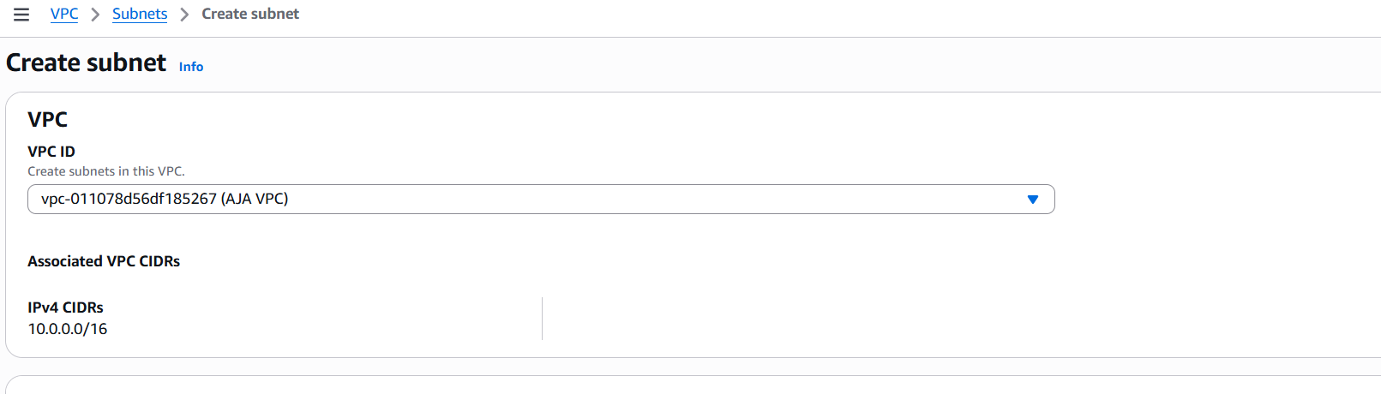

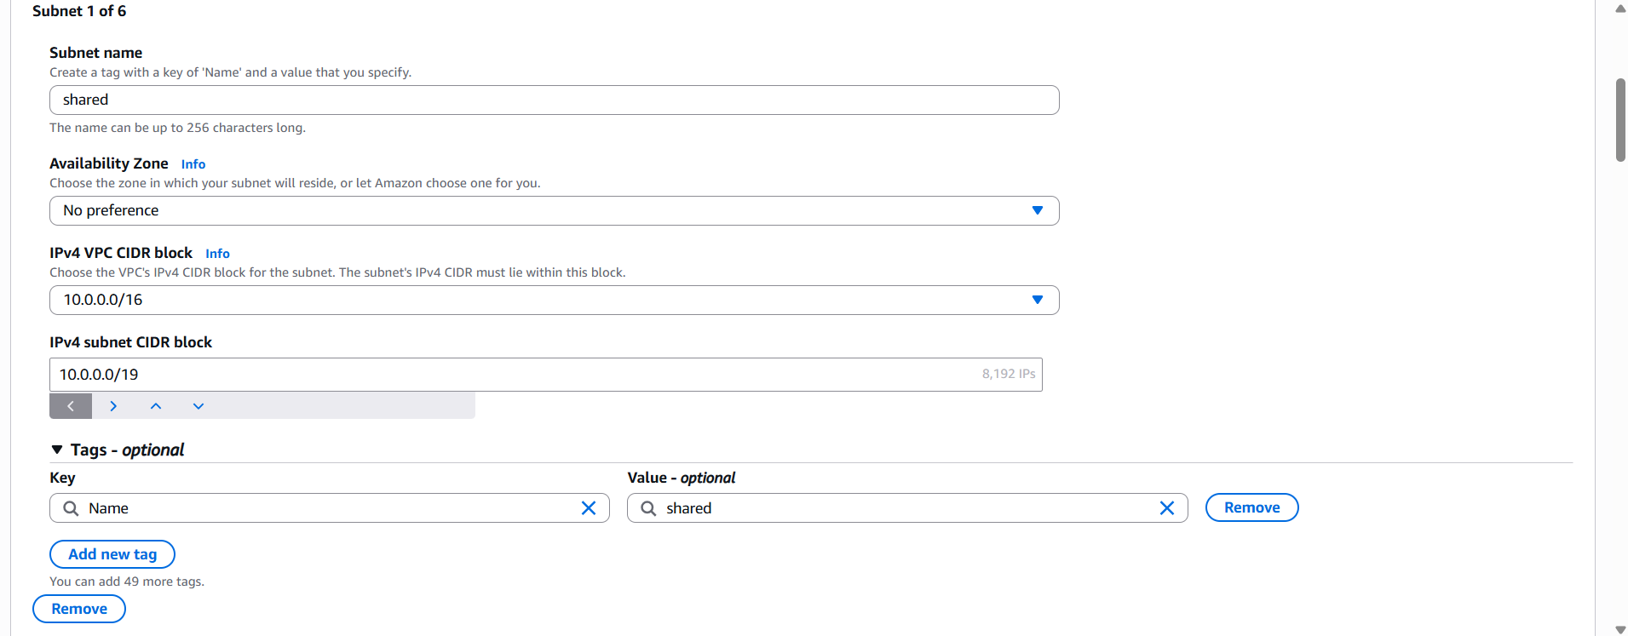

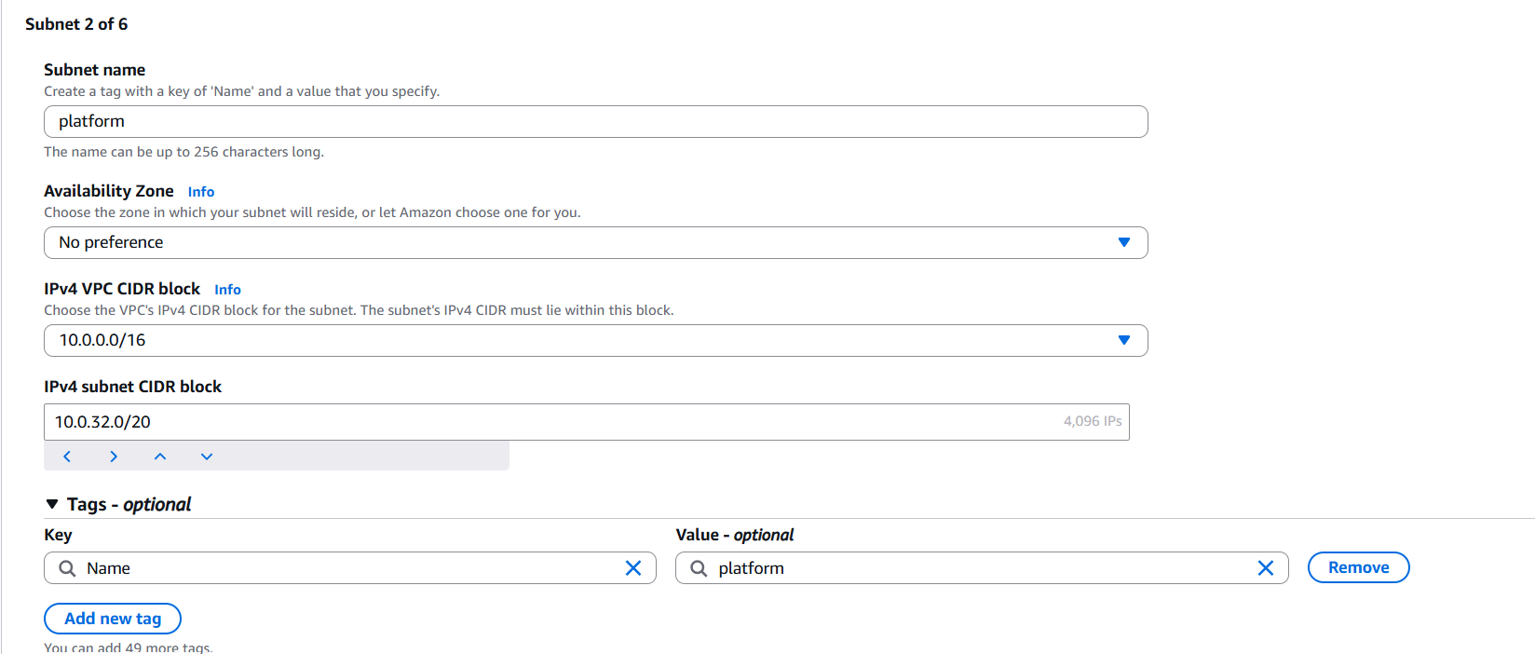

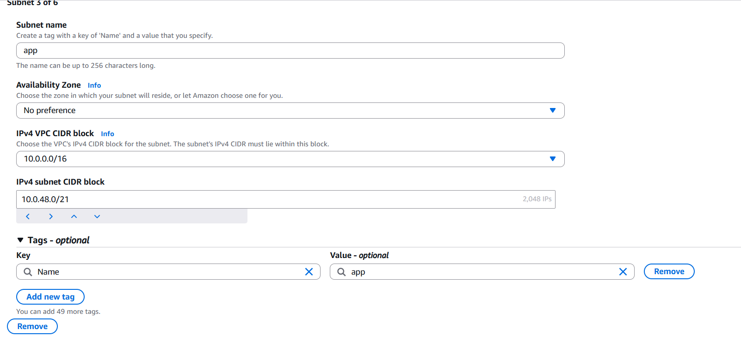

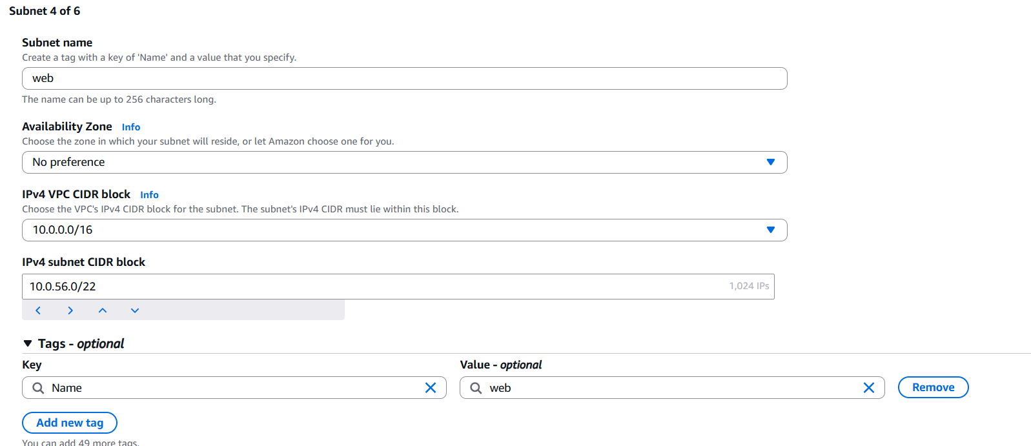

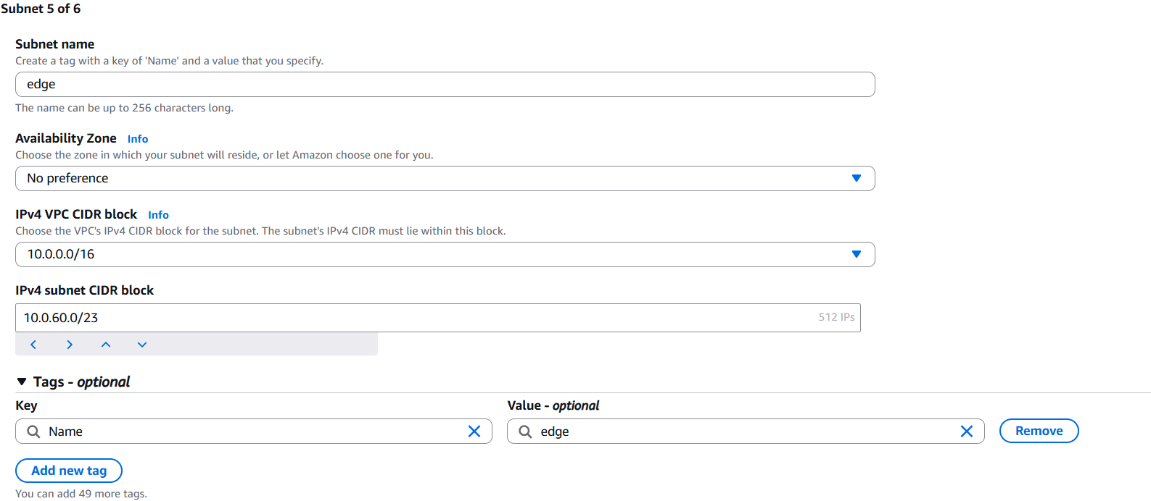

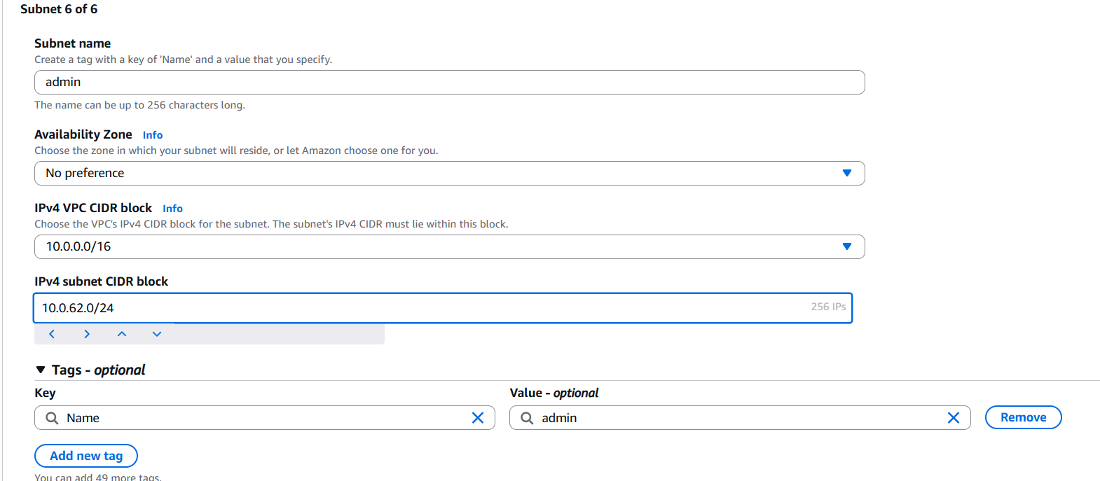

Internet Gateway Configuration
Internet Gateway
Component | Configuration

Internet Gateway | One IGW

Attachment Attached to VPC 10.0.0.0/16
Purpose
- Enables outbound internet access
- Traffic flows only if explicitly routed
- Supports audit and compliance requirements.

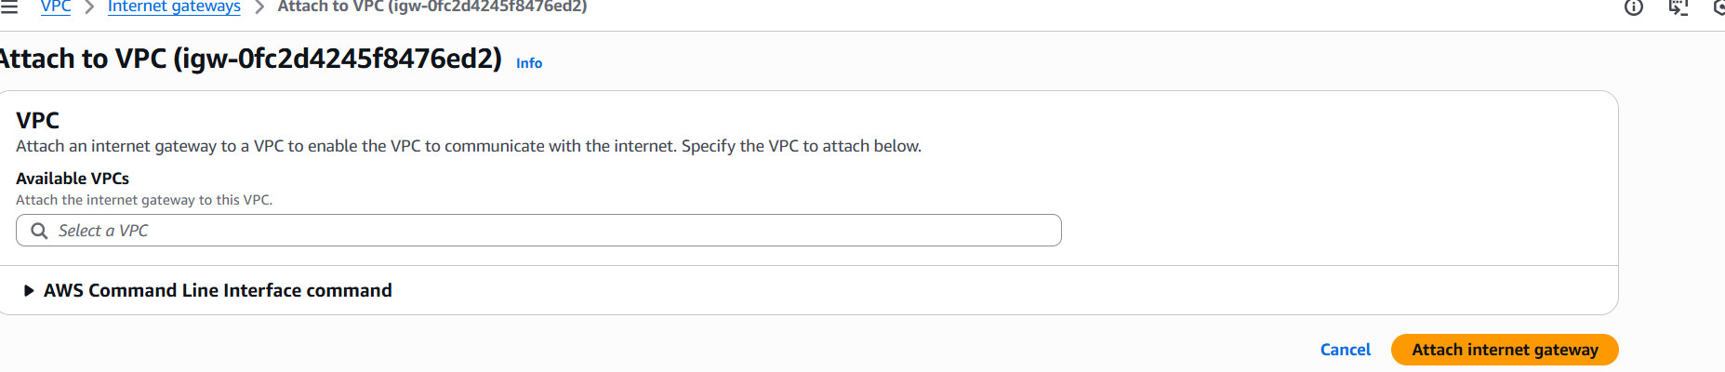

Route Table
A route table is used to control where network traffic goes from a subnet.
Route table = traffic decision maker

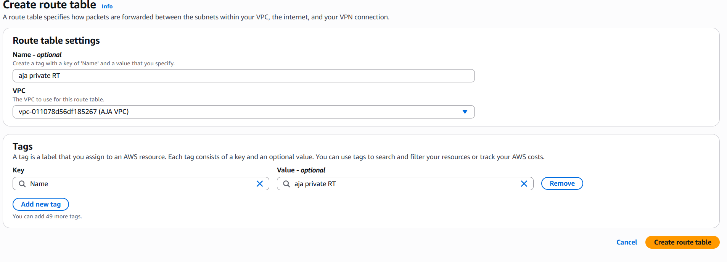

So here I divided subnets to public and private.
Through this we can access easily.

Private Route Table – Edit Routes
Routes to configure
Destination | Target
10.0.0.0/16 | Local
Public Route Table – Edit Routes
Routes to configure
Destination | Target
10.0.0.0/16 | local
0.0.0.0/0 | Internet Gateway (IGW)

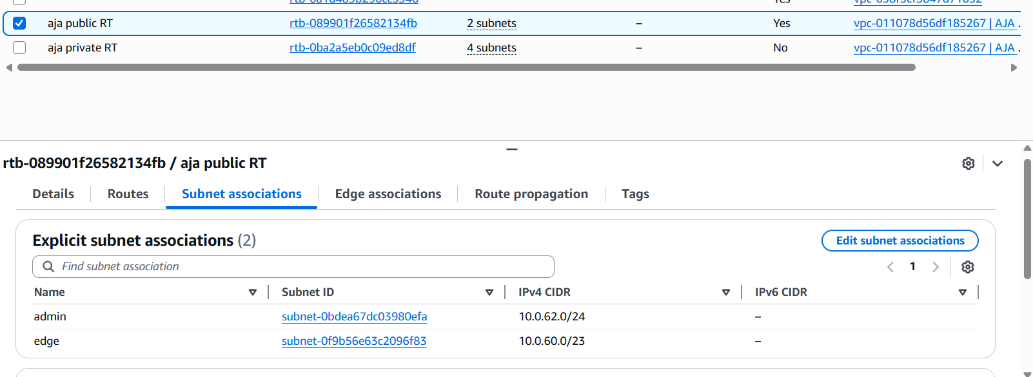

So here are the public subnets:

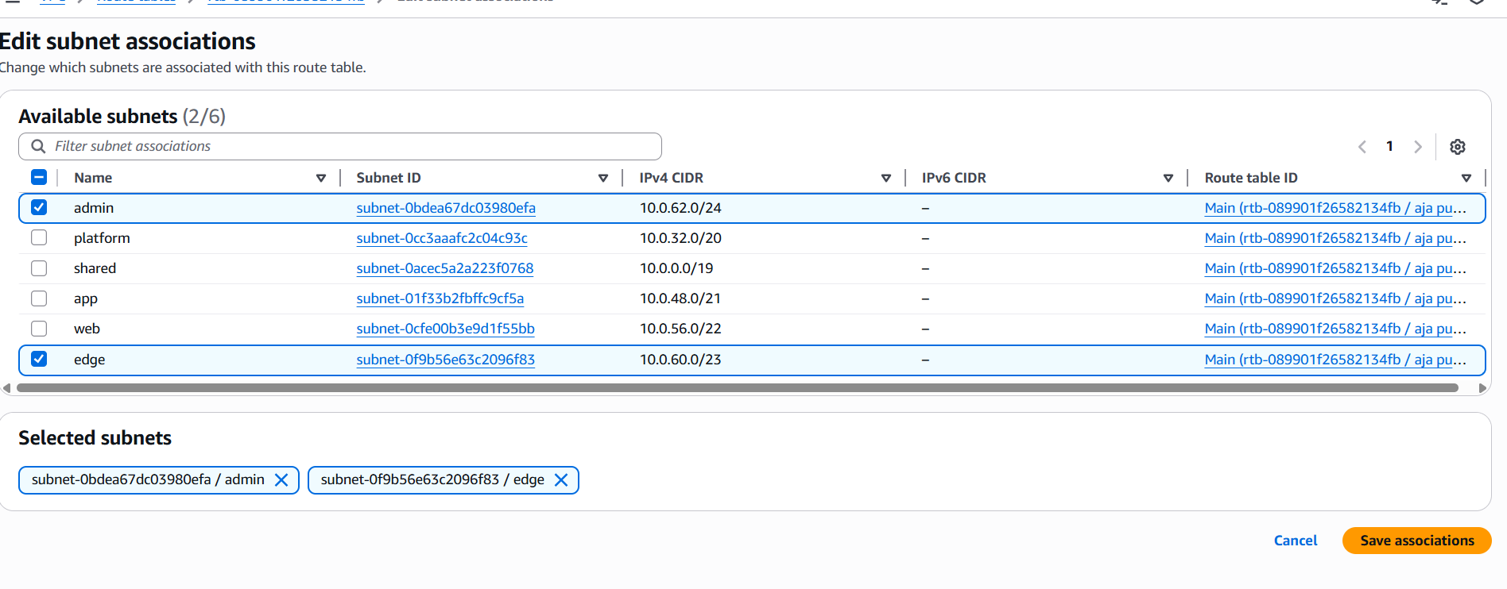

And the private subnets:

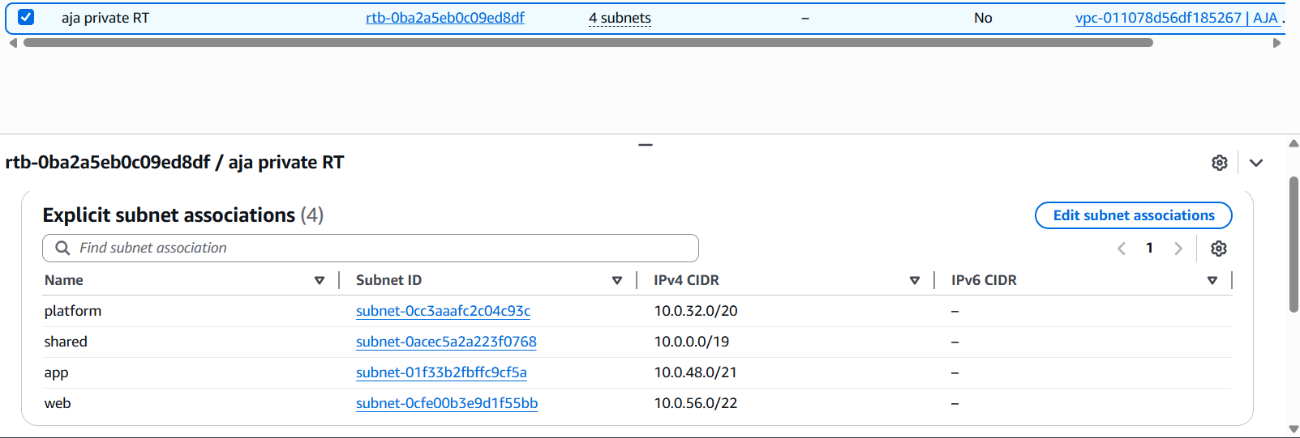

Edit Routes
Edit routes is where you define where traffic from a subnet is allowed to go.

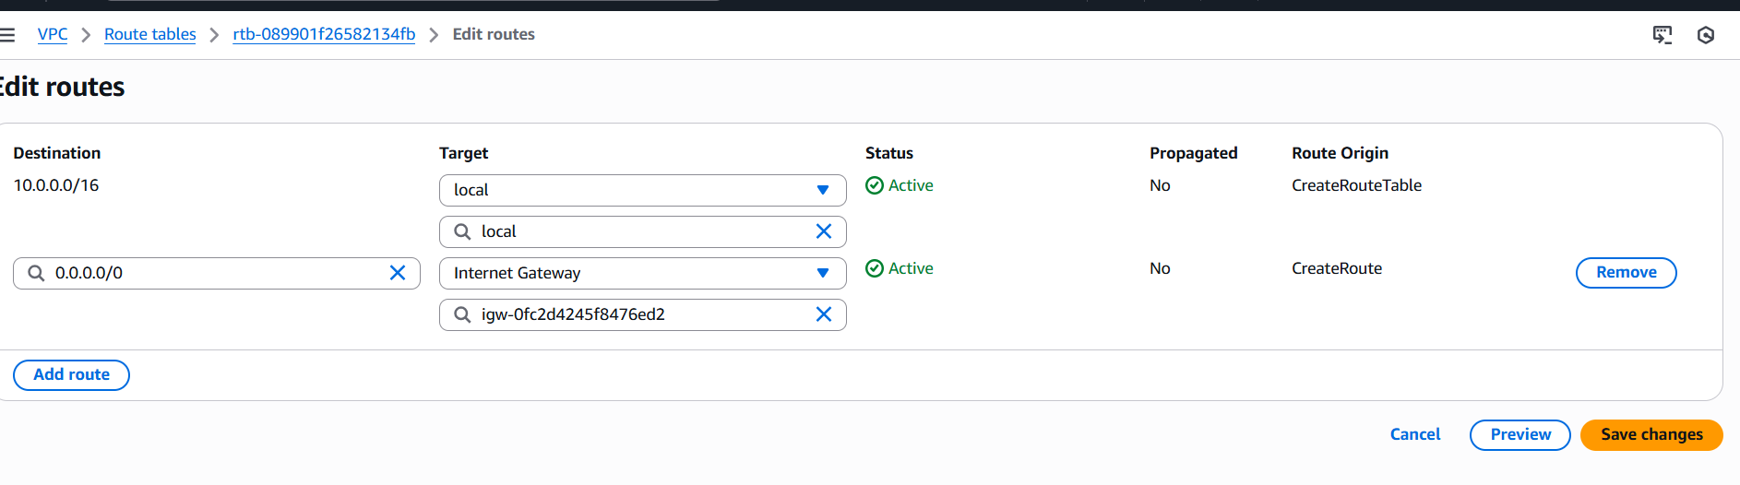

The presence of a public IPv4 address and successful login confirms that the subnet is associated with the public route table.

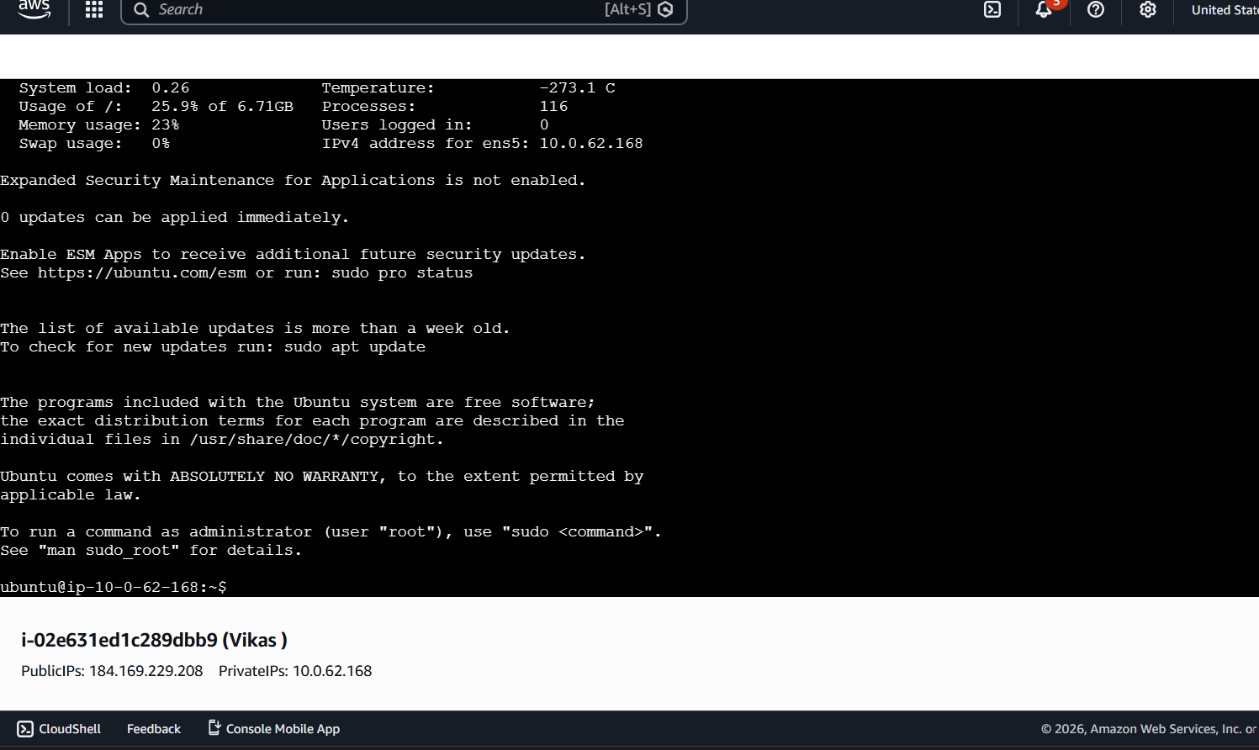

The connection failure validates that the private subnet is correctly isolated and does not have a default route to the Internet Gateway.

